Executing jmx scripts on the remote perf environment.

1) Ensure the wager limits are set high enough that the test will complete. These can be found at https://abpjmsperf.toto.org.il:8443/abp/olympus2/?app=wager-limits, log in as LVS with password a and set them wagers as high as needed.

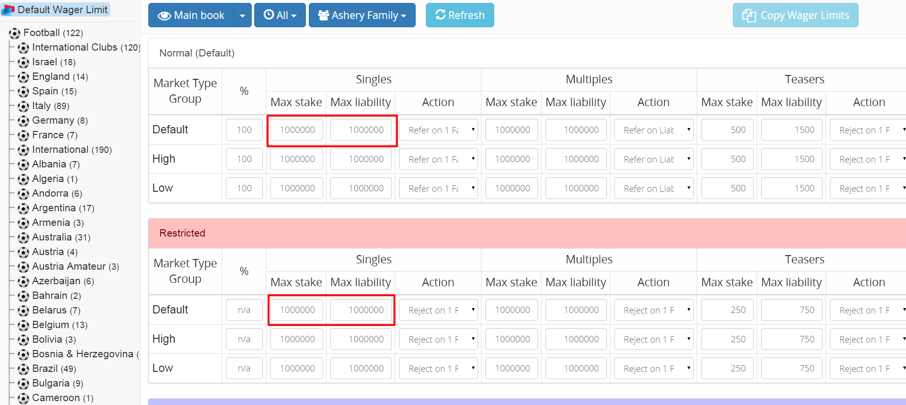

3) Download and amend the script that will be executed, to do this open WinSCP, log on to 10.0.92.60 as username "root" with password "Aa123456". The directory you will require is "/home/Injectors/apache-jmeter-2.9/extras", select the jmx you will require and download it. If a large run (100 plus threads) is anticipated ensure the "View Results Tree" is only logging errors as otherwise this could get to big to be opened.

4) Amend the "jp@gc - Stepping Thread Group" step to reflect ramp up, running time and number of threads you wish. Also amend the "View Results Tree" and "Aggregate Report" so they create a new file, they should save the file to "/home/Injectors/apache-jmeter-2.9/extras/results/" with a unique filename appended.

5) Save the file and upload it again to the JMSPERF environment (ensure it is to the "/home/Injectors/apache-jmeter-2.9/extras" folder).

6) Create a new list of outcomes for the jmx script to execute. The script to run is this one.
set heading off
set arraysize 1
set newpage 0
set pages 0
set feedback off
set echo off
set verify off
spool 'c:\Code\List.csv'
select o.id ||','|| o.marketid ||','|| o.markettypeid from markets m , outcomes o where o.marketid=m.id and o.markettypeid !='28' and m.id in
(select distinct m2.id from
(select m.id from outcomes o join markets m ON (o.marketid = m.id ) where o.marketid IN
(select distinct id from markets where statusid =
(select id from status where description = 'Open')
)) m2 join
(select m1.id from markets m1, marketlineconfig ml where m1.id=ml.marketid and ml.allowsinglebetsyn = 1) m3
on m2.id=m3.id
join (select marketid from outcomes where id in (SELECT OUTCOMEID FROM PRICES WHERE DECIMALPRICE > 1) ) m4 on m3.id=m4.marketid);
spool off
This can be saved into a file with a dot sql suffix. It is then run from the Oracle SQL Developer by opening the "perftest" connection and executing the sql from the local machine (the command is "@c:\your file structure\yourfilename.sql"). Note the line:
spool 'c:\Code\List.csv'
will need to be amended to reflect where you want the "List.csv" to be on your file structure.
The first two lines in the CSV will need to be deleted, these are title lines and not data but the system will read them.
The "List.csv" file will need to be uploaded to the "/home/Injectors/apache-jmeter-2.9/extras" folder.

7) Open a Putty session to "10.0.92.60" using the username "root" and the log in "Aa123456". Navigate too 10.0.92.60 "/home/Injectors/apache-jmeter-2.9/bin" then start the injector with the command "./jmeter-server".
Open another Putty session and navigate to "/home/Injectors/apache-jmeter-2.9/bin", run the command
sh jmeter.sh -n -t /home/Injectors/apache-jmeter-2.9/extras/TESTNAME.jmx -l /home/Injectors/apache-jmeter-2.9/extras/scriptresults.jtl -R 10.0.92.60:9200

This will begin the execution.

8) When the execution has finished the files will be available in the directory specified on the remote machine "/home/Injectors/apache-jmeter-2.9/extras/results/", download this using WinSCP to a local directory. Open an instance of Jmeter with a new test plan. From the listeners menu add an Aggregate Report.
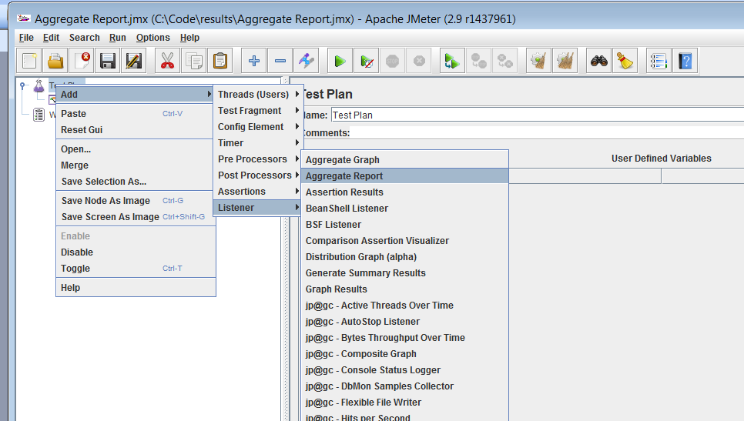

Using the aggregate report, open the aggregate report that was just created by the jmx and downloaded earlier in this step.
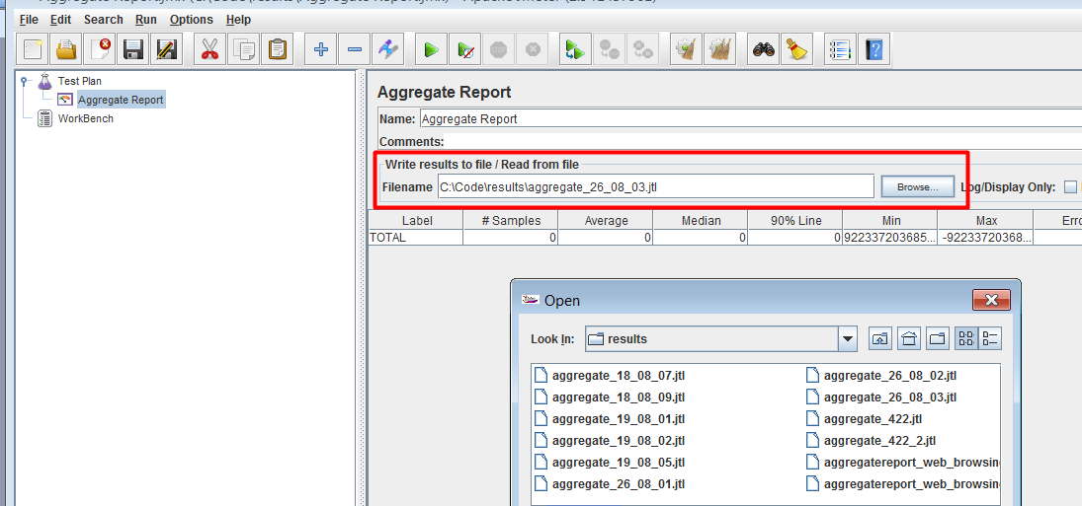
This will open and display the Aggregate Report. The Summary Report follows a similar path.

